Creating a New AWS EC2 Instance – On‑Demand Kali Linux Server

This guide provides step‑by‑step process to deploy a Kali Linux server virtually on Amazon Web Services (AWS), configure secure access, deploy a website, and manage services.

1. AWS Login and Instance Launch
1. Sign in to the Amazon Web Services (AWS) Console.
2. Navigate to **EC2 → Instances → Launch Instance**.
3. Configure instance details.
4. Create a new RSA key pair (.pem) and download it securely.
5. Launch the instance.
Amazon Web Services Sign-In
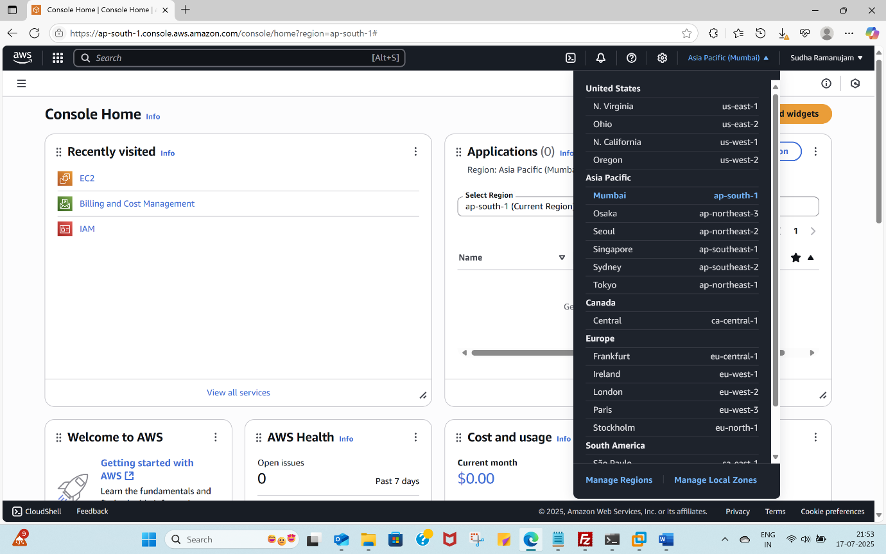
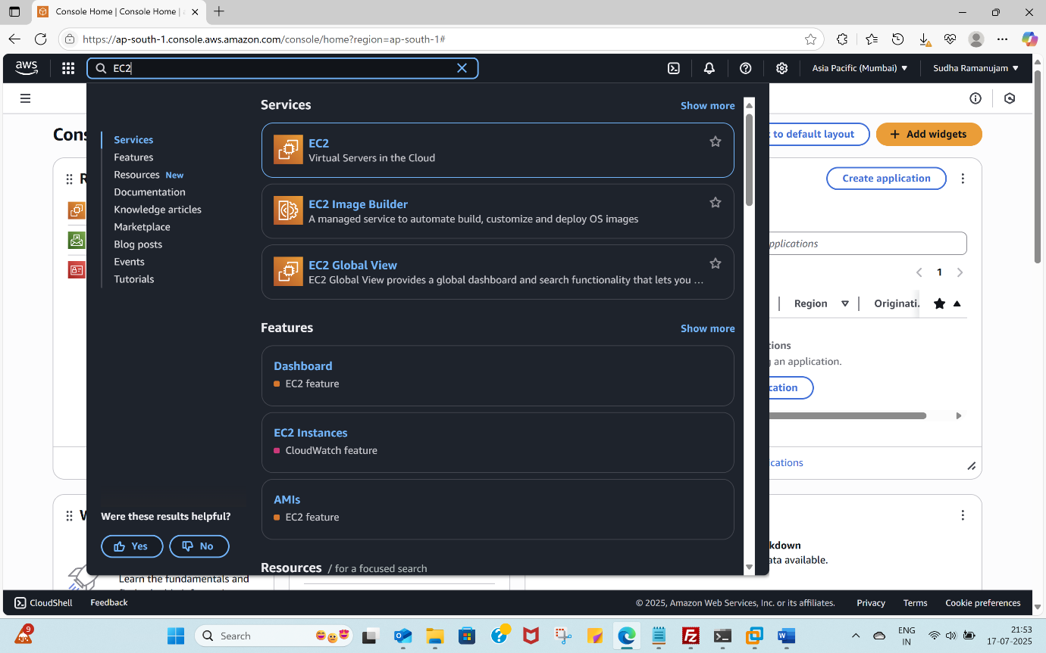

Launch Instance
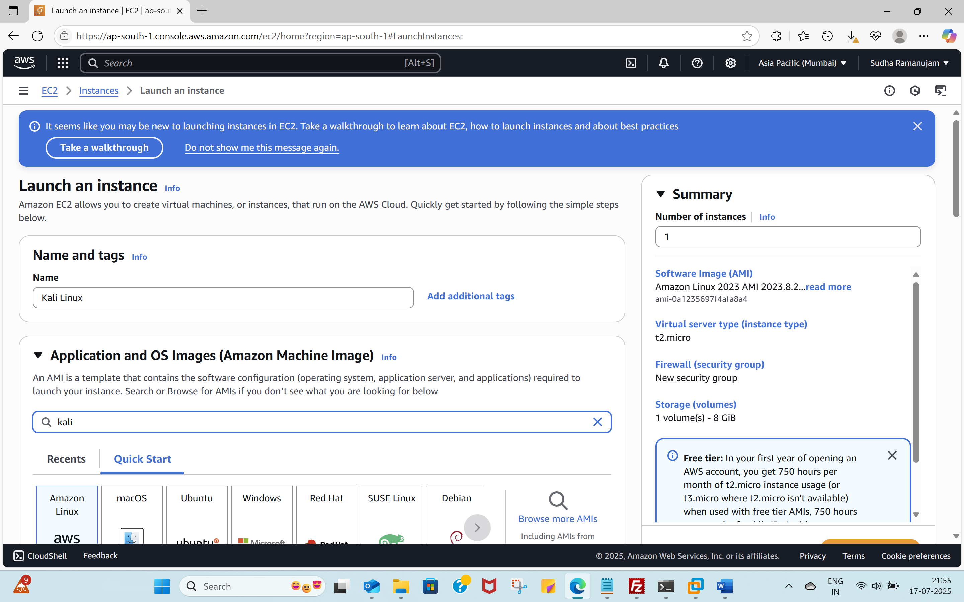
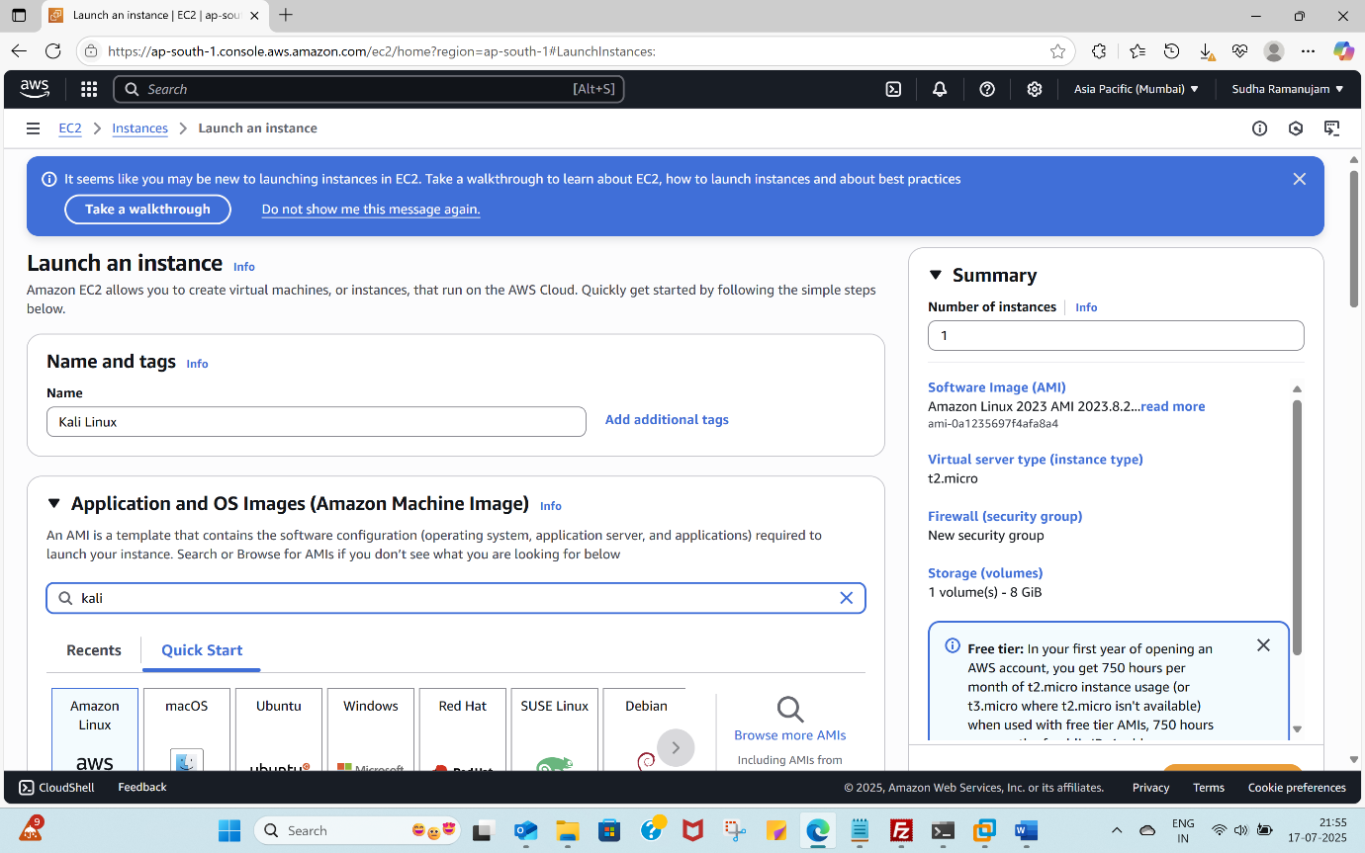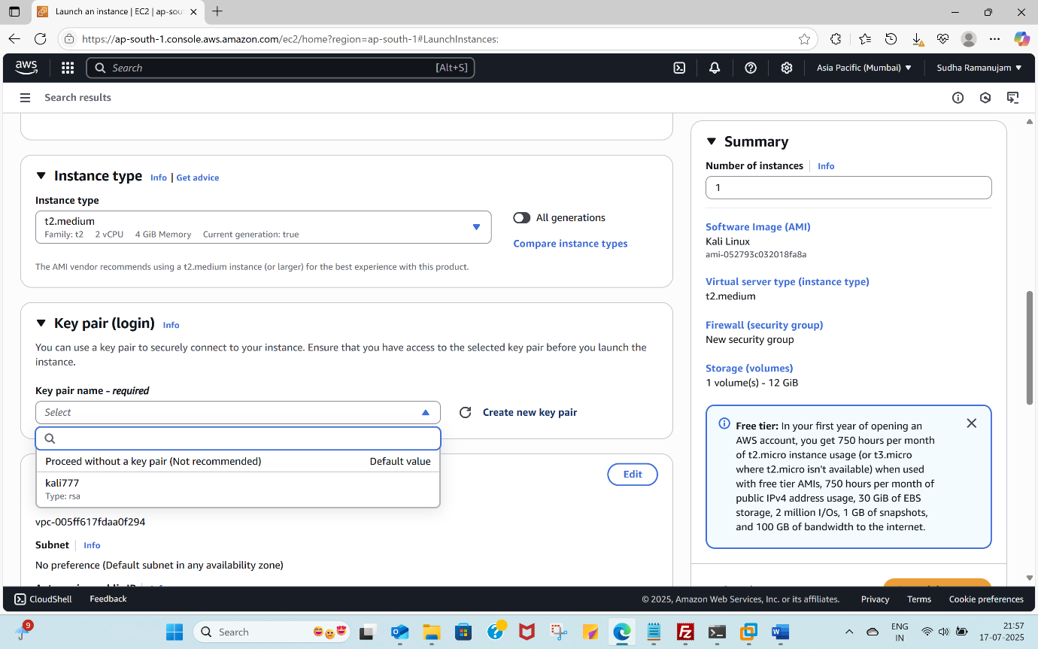
Create key pair -> RSA -> .pem
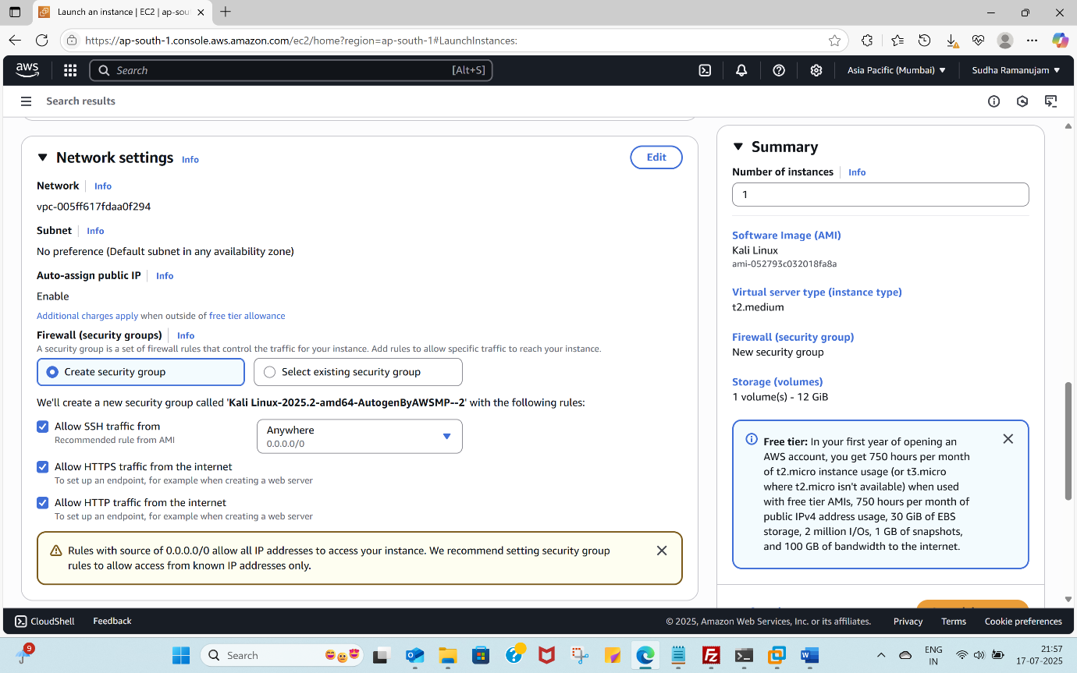
LAUNCH INSTANCE

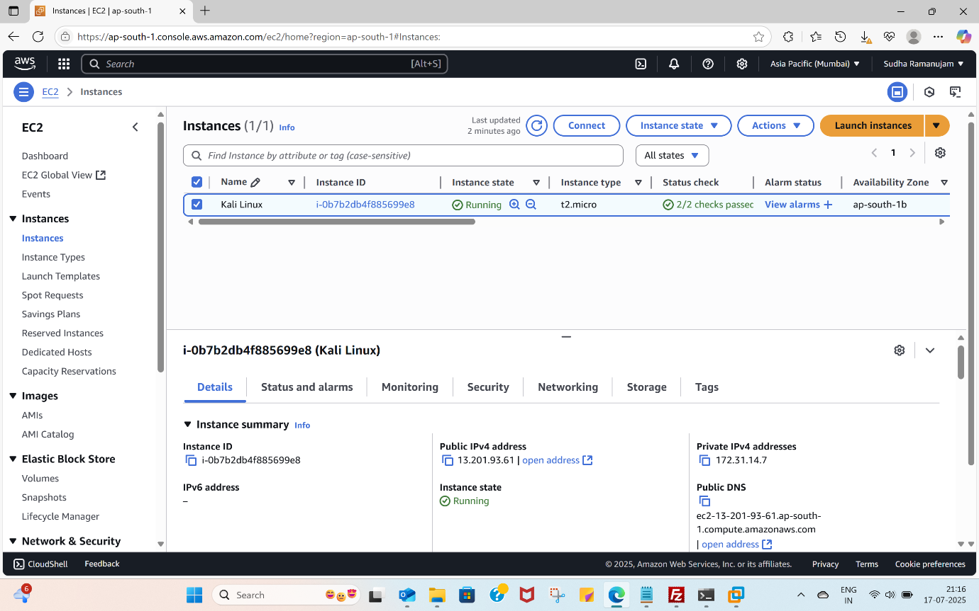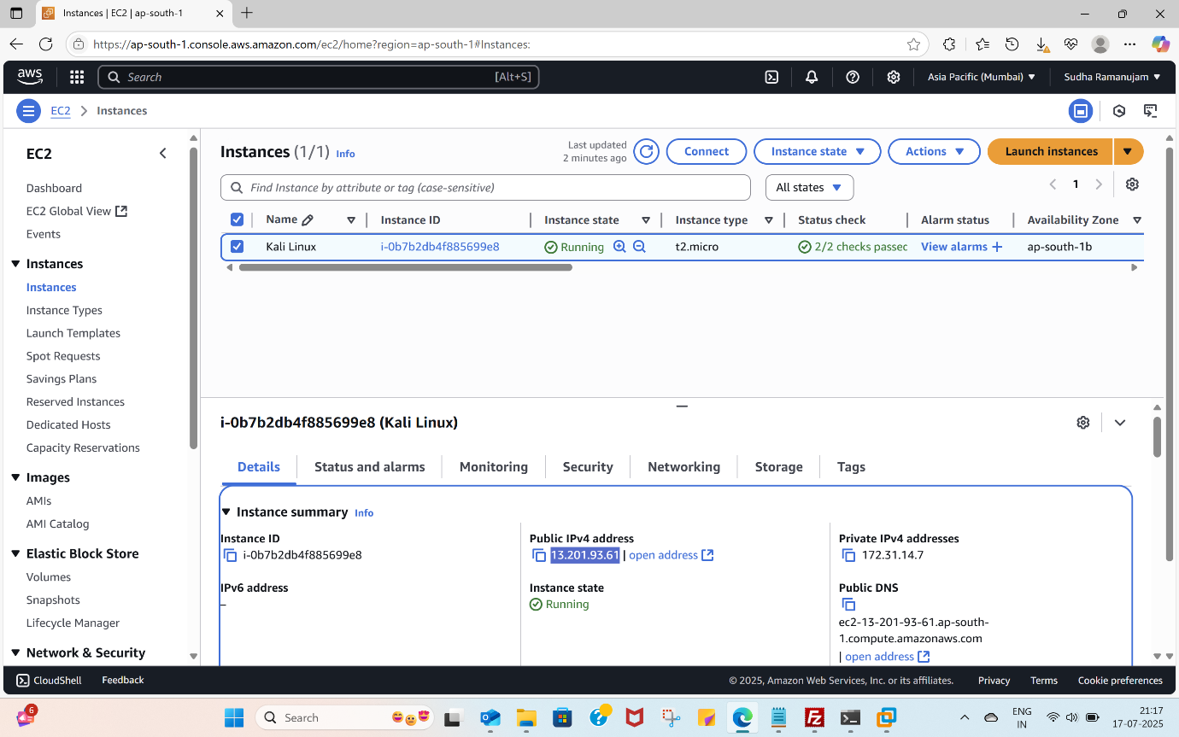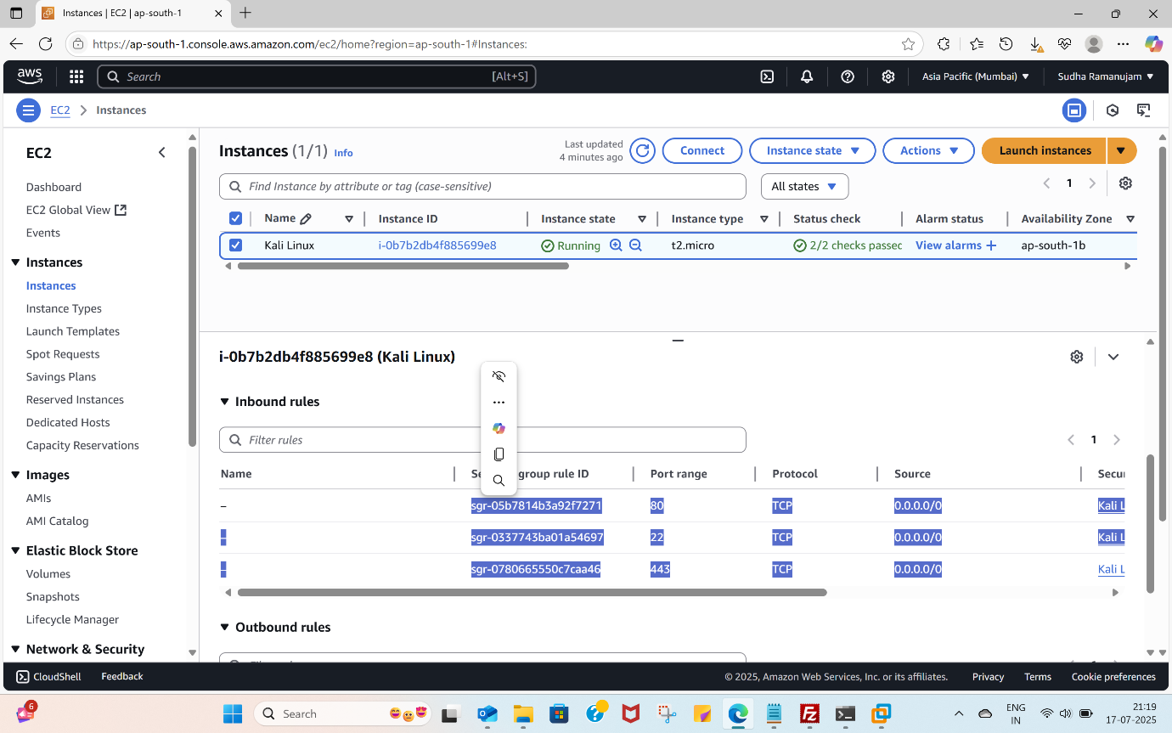
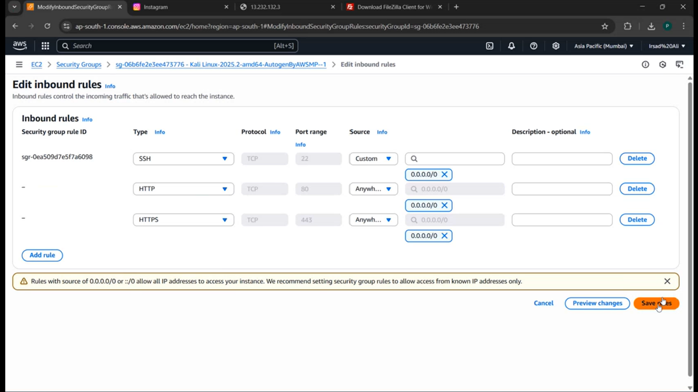

2. Connecting via SSH
Use the following format:
ssh -i "<path-to-pem-file>" kali@<public-ip>

Example:
ssh -i "C:\\Users\\HP\\Downloads\\kali777.pem" kali@65.1.95.138

Then:
sudo su

3. Update System Packages
apt-get update && apt-get upgrade -y

4. Install Apache
apt install apache2 -y

Navigate to the hosting directory:
cd /var/www/html

Set testing permissions (not recommended for production):
chmod 777 /var
chmod 777 /var/www
chmod 777 /var/www/html

5. Upload Files Using FileZilla
Connect via SFTP and upload site files (index.html, login.php, etc.) to /var/www/html.
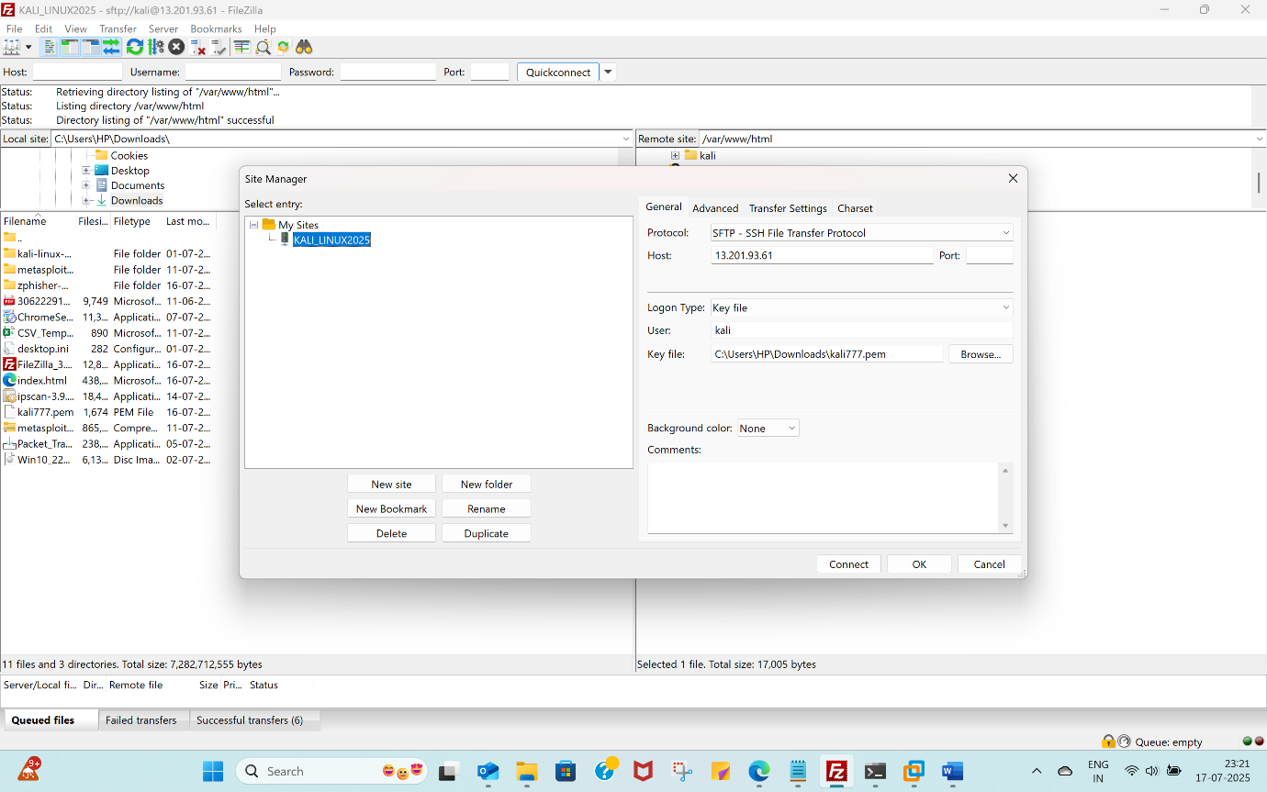

6. Start/Stop Apache Service
Start:
service apache2 start

Stop:
service apache2 stop

7. Stop AWS Instance
Stop the instance from AWS console to avoid charges.

8. Notes for Website Deployment
- Rename main file to index.html
- Upload all required backend files
- For Zphisher-generated templates, save as index.html and upload

9. Enhancement
Using zphisher created a fake website
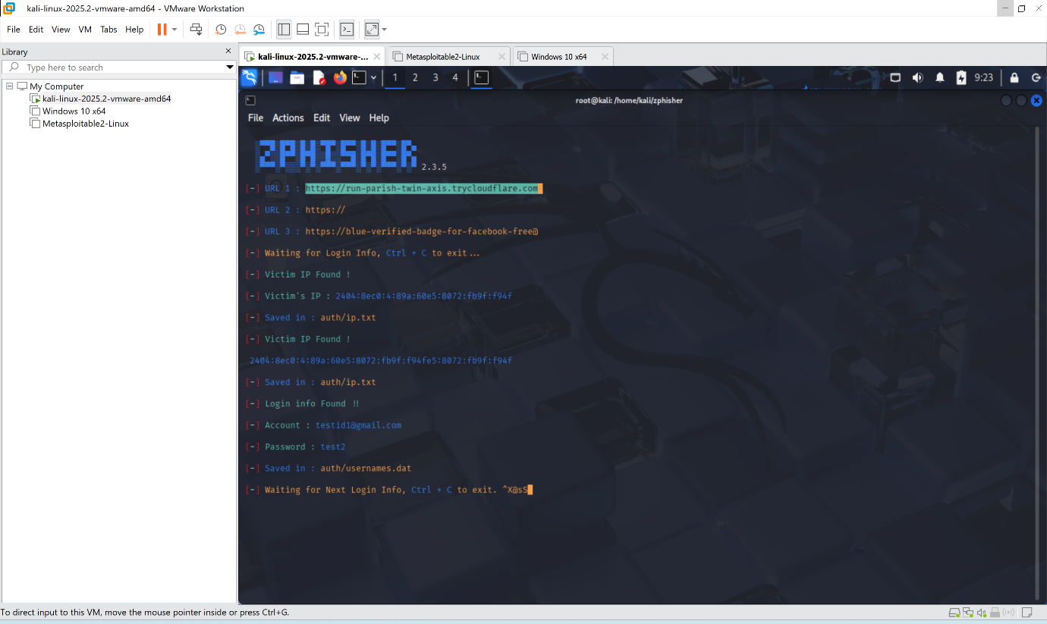
Go to that website right click and save as html webpage named as index
Upload this file to var/www/html server location using FileZilla to deploy the fake website to perform Phishing attack – specifically credential harvesting

